Prepare your setup

On control server

We also need access to the “Extra Packages for Enterprise Linux” for downloading packages outside the normal channels

yum install wget vim

wget https://dl.fedoraproject.org/pub/epel/epel-release-latest-7.noarch.rpm

rpm -ivh epel-release-latest-7.noarch.rpm

yum install epel-release

### Step 1 – Installing Python, Python Tooling & Ansible

1. We’ll install Python first

sudo yum install python

2. Next we’ll install PIP which is a “package management system used to install and manage software packages written in Python”

yum install python-pip

3. Now we need to upgrade it

pip install --upgrade pip

4. Next we’ll use PIP to install some libraries and modules for python & Ansible

pip install markupsafe

pip install xmltodict

sudo pip install pywinrm

• And finally we will install Ansible

yum install ansible

• To confirm that it has been installed correctly we’ll execute

ansible --version

There are some configuration changes in quick start in the configuration file in order to get started with ansible.

# vim /etc/ansible/ansible.cfg

(The ansible configuration file lets go and edit)

Will go the Default section and edit some changes: -

Will just uncomment as shown in the below image for inventory and sudo_user

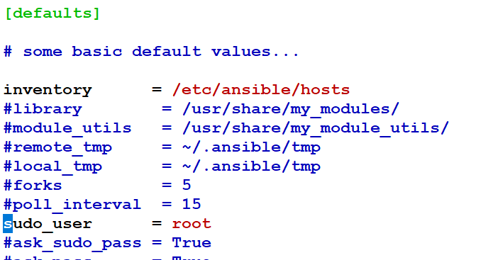

Sudo_user why we are uncommenting is because whenever we use sudo that will work as a root user.

Inventory is to determine that to look on certain hosts local file and in this case we will have globally available host file.

In ansible there is no daemon running to restart after the configuration changes in the file. Ansible will read its configuration file every time you made changes.

Before editing the original file please move that to a new file

# mv /etc/ansible/hosts hosts.original

Ansible finds its nodes by names or dns names or values that are listed on hosts file

# vim /etc/ansible/hosts

Here wehave to set up groups and they are identical by brackets [ ]

Ex: - hostnames for our nodes are Server-controlserver, centos-node1, ubuntu-node2

Our configuration file looks like: -

[localhost]

controlserver

[centos7]

centos.iselglobe.com

[ubuntu1604]

ubuntu.iselglobe.com

Save ad exit the file :wq!